

***FREE TRAINING***

***Do you work with Young People who may Babysit? Volunteer at a Youth Group? Or are just interested in learning more about Safeguarding?***

The NSCB offers free online training to young people aged 11-18 on basic safeguarding.

Simply visit [northamptonshirelscb.safeguardingchildrenea.co.uk](https://northamptonshirelscb.safeguardingchildrenea.co.uk/) and register to take the ‘Think Safe, Be Safe, Stay Safe’ Course.

[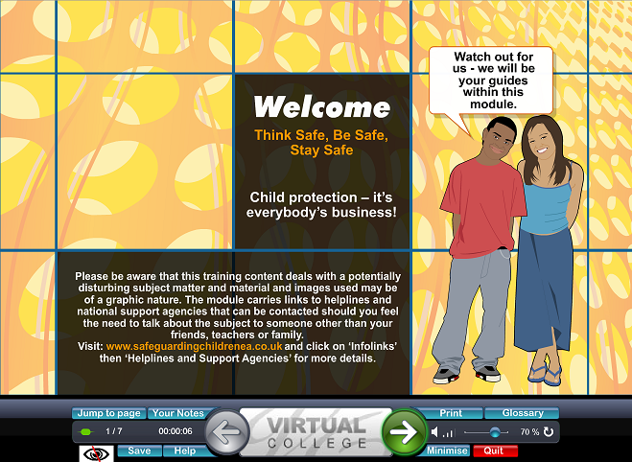](https://northamptonshirelscb.safeguardingchildrenea.co.uk/Images/ThinkSafeBeSafeStaySafe.png)

When completing the course you should select Young Person and have 4 weeks to complete the course



***FREE TRAINING***

***Do you work with Young People who may Babysit? Volunteer at a Youth Group? Or are just interested in learning more about Safeguarding?***

The NSCB offers free online training to young people aged 11-18 on basic safeguarding.

Simply visit [northamptonshirelscb.safeguardingchildrenea.co.uk](https://northamptonshirelscb.safeguardingchildrenea.co.uk/) and register to take the ‘Think Safe, Be Safe, Stay Safe’ Course.

[](https://northamptonshirelscb.safeguardingchildrenea.co.uk/Images/ThinkSafeBeSafeStaySafe.png)

When completing the course you should select Young Person and have 4 weeks to complete the course