Version: 1.3
Date: July 2020

Take Action Today, Put them away: Northamptonshire

Briefing pack for local partners

Introduction
Take Action Today, Put Them Away is a major programme to promote awareness and prevent accidents with household cleaning products. Poisoning continues to be an important public health issue in the UK. It accounts for over 5,000 overnight admissions of 0-4 year olds in England per year between 2014/17. Hospital admission data does not reflect the very many poisoned patients who present to hospital Emergency Departments (A&Es) across the UK who are not subsequently admitted overnight. It also does not take into consideration the large number of enquiries about poisoning received by NHS public access help lines: NHS Direct and NHS 111 in England and Wales and NHS 24 in Scotland.

Because of their inquisitive nature, children under five years of age are most at risk. Few of them die, or require little or no further treatment, but the anxiety and distress caused to both child and parents could be avoided by increased awareness.
Fig 1: Age of poisoned patients as reported in telephone enquiries to the NPIS in 2015/16
Source: National Poisons Information Service (NPIS)

Figure 2 below highlights that whilst pharmaceutical products continue to be the items most involved in reports to the National Poisons Information Service (NPIS), household products, chemicals and cosmetics continue to be involved in a significant number of poisonings.

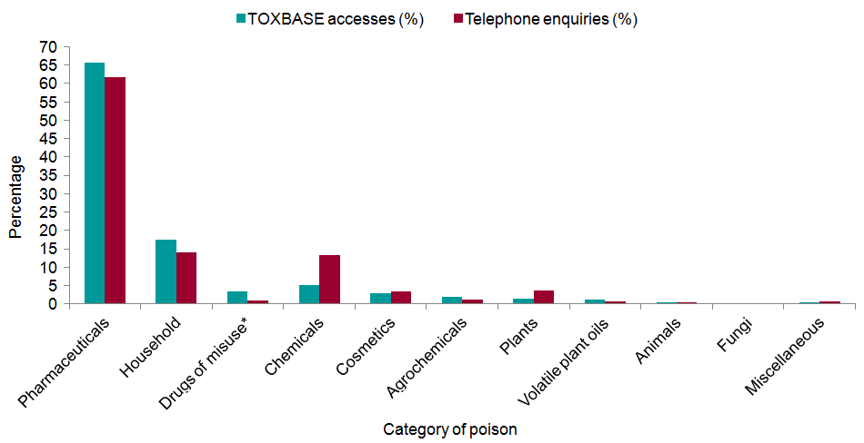
Figure 2: Types of agents involved in telephone enquiries to the NPIS and TOXBASE access in 2017/18
Source: National Poisons Information Service

Household cleaning products are not reported in detail by NPIS every year but the most recent report shows that the most commonly accessed ingredients are surfactants, e.g. those found in washing powders, liquid detergent capsules or dishwasher tablets and bleaches.

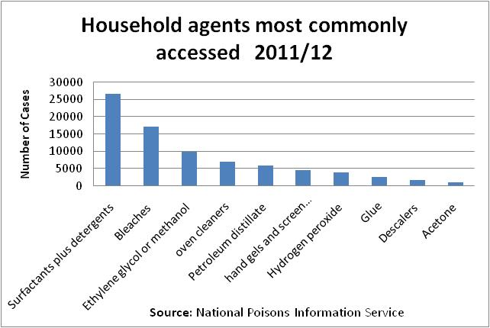
Figure3: Household agents commonly accessed
Potentially harmful substances, such as cleaning products used in and around the home, are often stored under the sink. Laundry liquids and floor cleaners are often packaged in brightly coloured wrappers, which may attract young children.
Telephone enquiries to the NPIS regarding soluble dishwasher and laundry detergent tablets were analysed retrospectively for the period January 2008 to December 2015. There were 498 enquiries relating to 488 patients. Almost all exposures occurred in the home (98.4%) and involved children aged five years or less (92.8%). Exposure occurred mainly as a result of ingestion alone (470, 96.3%). Eye contact alone (9, 1.8%) and exposures involving multiple routes i.e. ingestion with skin or eye contact (9, 1.8%) made up the remaining cases.
NPIS does not record all cases of poisoning but reports on enquiries made to its telephone advisory service, usually by clinicians. It therefore provides a useful picture of what is happening in relation to poisoning but the number of incidents is likely to be much higher than those recorded by NPIS as not every case is reported to them.

East Midlands Region
Admissions for poisoning across the East Midlands region are below the national average.
Emergency admissions for accidental poisoning in children aged 0-4 2016/17 - 18/19

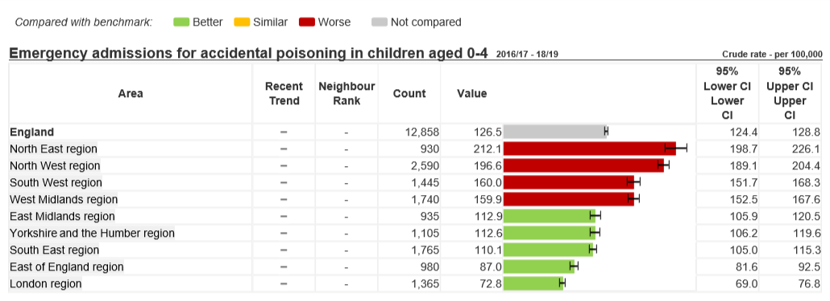

Northamptonshire
Although poisoning rates in the East Midlands are below the national average in Northamptonshire they are only classed as similar to the national average for England. Therefore, there is work to be done to reduce these figures, which suggests that there is a need to help families understand the dangers of poisoning and the importance of maintaining a clear accident prevention strategy within their home. This will enable them to take the precautions necessary to improve the safety of their children and reduce hospital admissions due to poisoning.

Emergency admissions for accidental poisoning in children aged 0-4, 2016/17 - 18/19
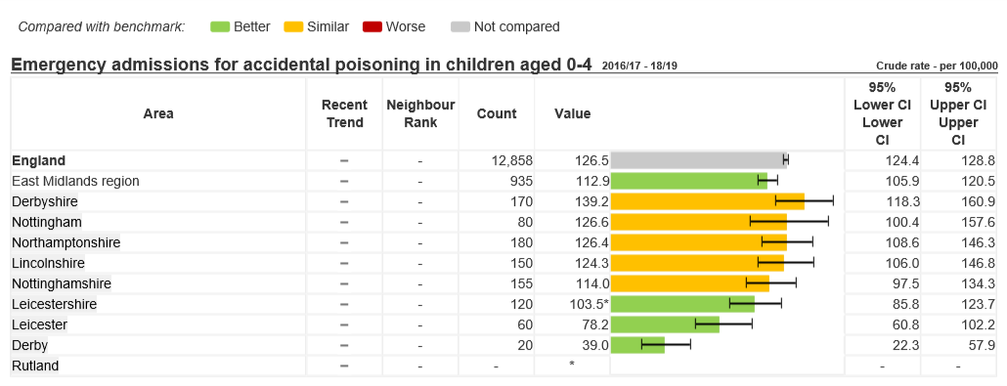
Fig 5: Emergency admissions for accidental poisoning of children aged 0-4 in Northamptonshire 2016/17 - 18/19
Source: PHE Fingertips database

This briefing pack outlines a project developed in consultation with the UK Cleaning Products Industry Association (UKCPI) for an awareness-raising programme to be delivered to the public to promote awareness of the dangers of household cleaning products. It will do so by providing information and resources that will equip the consumer with the skills to recognise the dangers and take steps to prevent accidental ingestion of household cleaning products. In doing so it will communicate the key messages in relation to all types of household poisoning.

Aim of the programme
To provide suitable risk assessment tools and educational materials which will equip consumers with the skills and knowledge to ensure they are able to recognise potential dangers with regard to household chemicals.

Key elements of the programme

3.1 Education
Most poisoning accidents involve medicines, household products and cosmetics. Some poisoning agents can cause breathing difficulties. RoSPA will supply information material highlighting the key messages in relation to household poisoning. The messages will include:
- Keep medicines and chemicals out of sight and reach of children, preferably in a locked cupboard
- Wherever possible, buy products in child resistant containers
- Always store chemicals in their original containers
- Dispose of unwanted medicines and chemicals safely
- Keep electronic cigarettes and button batteries out of the reach of children
- Avoid buying plants with poisonous leaves or berries or those that can irritate the skin.
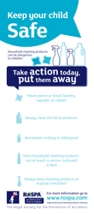

3.2 Provision of proven RoSPA assessment tools and resources
- A magnetic notepad has been produced to convey the important messages in relation to this issue
- A briefing pack that contains all the information necessary to support the delivery of the programme in your area
- A simple, effective assessment tool for use in and around the home
- Signposting to the RoSPA website for further information.

3.3 Website
A dedicated section on the RoSPA website includes:
- Key safety messages
- Downloadable versions of all materials produced for the programme
- A frequently asked questions section
- Videos, case studies and reports from programmes in other areas

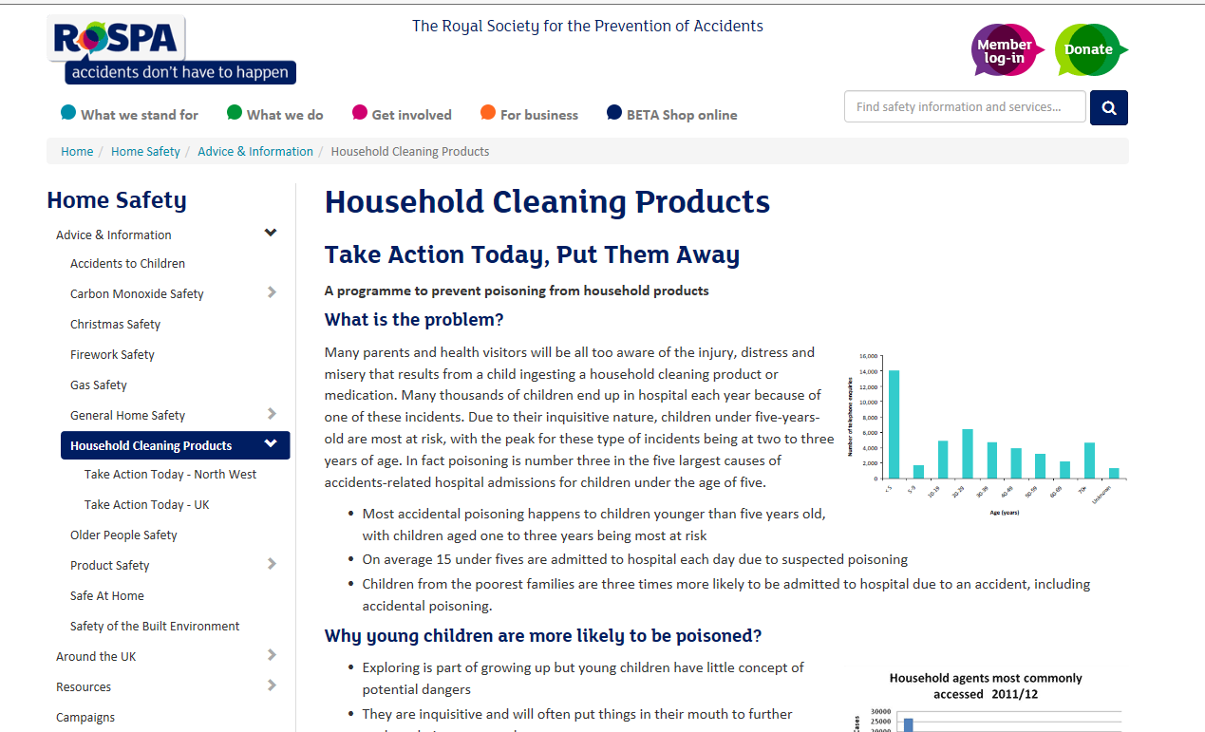

http://www.rospa.com/home-safety/advice/child-safety/household-cleaning-products/

3.4 Targeting and distribution
The programme will generate publicity and information that will be beneficial to all sectors of society but it is important to target limited resources at those most at risk. The focus will be on building partnerships, this will maximise the impact of both the practical and educational elements of the programme.

All local partners will agree to:
- Work with vulnerable clients, particularly families with children under five years of age
- Provide some feedback on the families who have received the materials
- Participate in the programme evaluation, including the provision of admissions and attendance data where possible
- Provide case studies of families who have had concerns about or incidents of household poisoning or who have benefitted from the programme.

Local delivery
A multiagency approach is planned to tackle this issue, including delivery through Children's Centres, Health Visitors, self-care programmes and information screens, for example in GP surgeries, A&E and Urgent Care Centres. Engagement will also take place with childminders and nurseries and maternity service user representatives will disseminate information through peer support networks. Work will also be undertaken with schools that provide foundation stage education and the programme will be promoted through partner websites and social media.
- The Health Visiting team
- Children’s Centres
- Self-care programmes and information screens
- Local hospitals, A&E and Urgent Care Centres
- Local Authority public health
- GP surgeries
- Early years settings – nursery, childminders, schools, community buildings, faith centres
- Maternity service user representatives
- A current E-learning module for front line staff includes home safety and poisoning messages.

All of the above agencies have direct contact with the proposed client groups. In some cases they are already providing services directly into the home.

Outcomes and key performance indicators
The proposed key performance indicators are:
- Number of partners participating
- Number of families involved in the programme
- Reduction in the number of children under five requiring treatment following the ingestion of a dangerous product.

Evaluation
Evaluation is a vital component of the programme - it will give valuable insight into the impact of the programme on household poisoning across the borough and will contribute to building a national picture and help to ensure that effective programmes can be delivered across the country.
The feedback received helps RoSPA to demonstrate the effectiveness of the programme, this evidence is needed to secure continuation of funds so that the programme can be offered to other areas.
To save you time we have developed a much quicker, web based feedback process. There are two versions, one for practitioners and another for parents. We encourage all of you to please complete the questionnaire and please also encourage parents to complete theirs.
Evaluation will include:
- Online feedback questionnaire for parents on the resources and how the resources have helped them to make their home safer - - https://www.snapsurveys.com/wh/s.asp?k=156466701015
- Online feedback questionnaire for local partners on how the programme has been received and has helped them to raise the issue of household poisoning – https://www.snapsurveys.com/wh/s.asp?k=155256348957
- Before and after comparison of local and national accidental poisoning statistics.

Public |Health England – Public Health Profiles - https://fingertips.phe.org.uk/profile-group/child-health

