How to Reset your Password

- If you have already accessed the NSCP suite of e-learning courses in the last 3 years but have forgotten your password it is very quick and simple to create a new one and access the system.

Please do not register for a second account, if you do so, any previous learning will be lost as accounts cannot be merged at a later date. If you are unsure whether you have an account please contact the Business Office on 01604 364036 who will be happy to check for you.

- In order to log in to the NSCP E-Learning and Face to Face training you should enter via the link below. If you use any other method, you may be charged for your training. This link can also be found in a number of places on the NSCB Website:
https://northamptonshirescb.vctms.co.uk/
- Click on the ‘Forgotten your login details?’ button
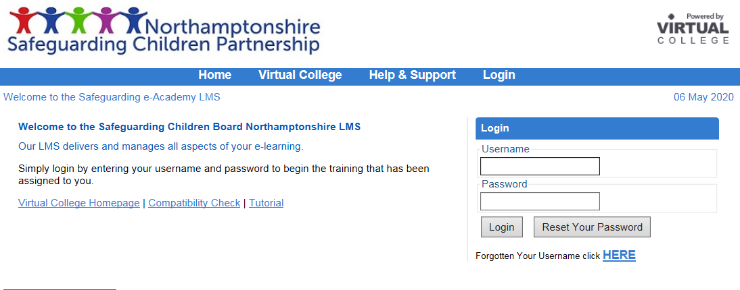
- Enter your username in the box and click to confirm you are not a robot, then select ‘reset your password’.
Your username is likely to be the e-mail address you registered with, you will need to still have access to this account to reset your password.

N.B If you have moved organisation and previously had an account please contact the Business Office who will be able to amend your details and ensure your historic learning is still available.
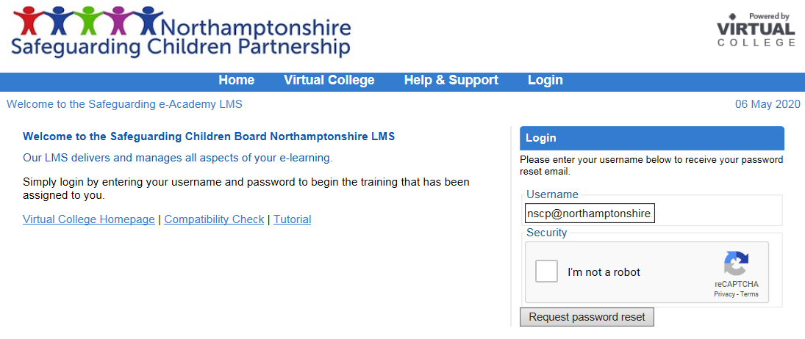

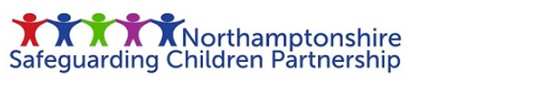
- You will then see the screen below and also receive a copy of the below e-mail where you will be able to reset your password by clicking the link.
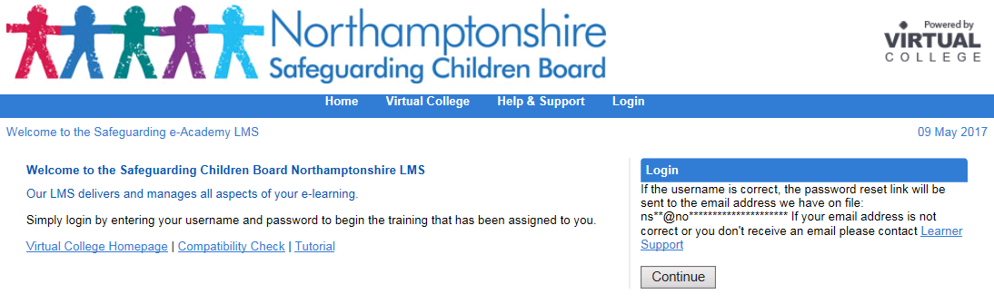
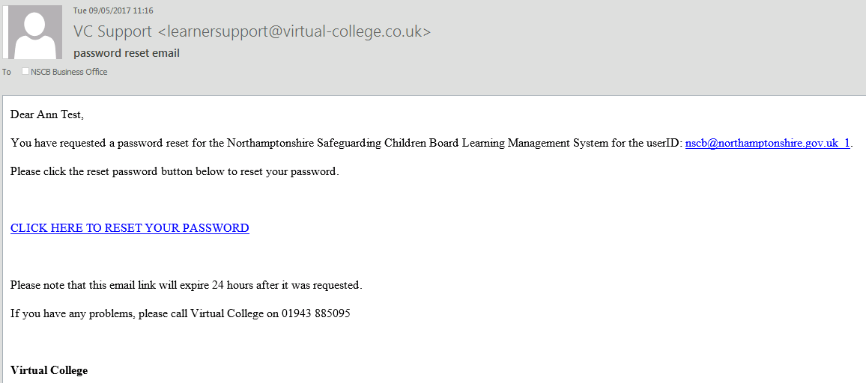

- You will then be able to reset your password on the following screen.
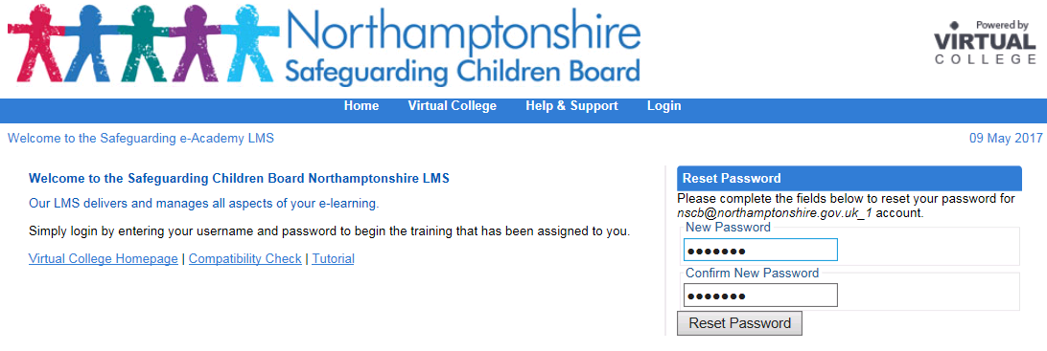
- Congratulations you have now reset you password and can log in as normal.
